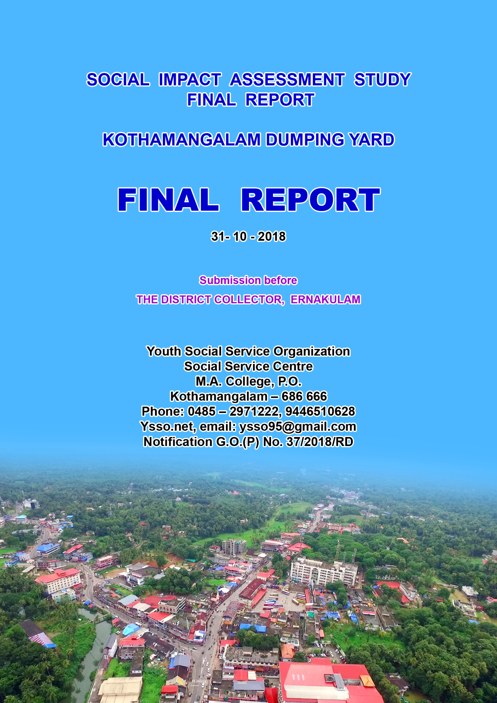

SOCIAL IMPACT ASSESSMENT STUDY
FINAL REPORT

KOTHAMANGALAM DUMPING YARD

31 - 10 - 2018

Notification G.O.(P) No. 37/2018/RD
District : ERNAKULAM
Taluk : KOTHAMANGALAM
Village : KOTHAMANGALAM

Submission before
THE DISTRICT COLLECTOR, ERNAKULAM

By
Youth Social Service Organization
Social Service Centre
M.A. College, P.O.
Kothamangalam – 686 666
Phone: 0485 – 2971222, 9645391500
Ysso.net, email: ysso95@gmail.com
Notification G.O.(P) No. 37/2018/RD

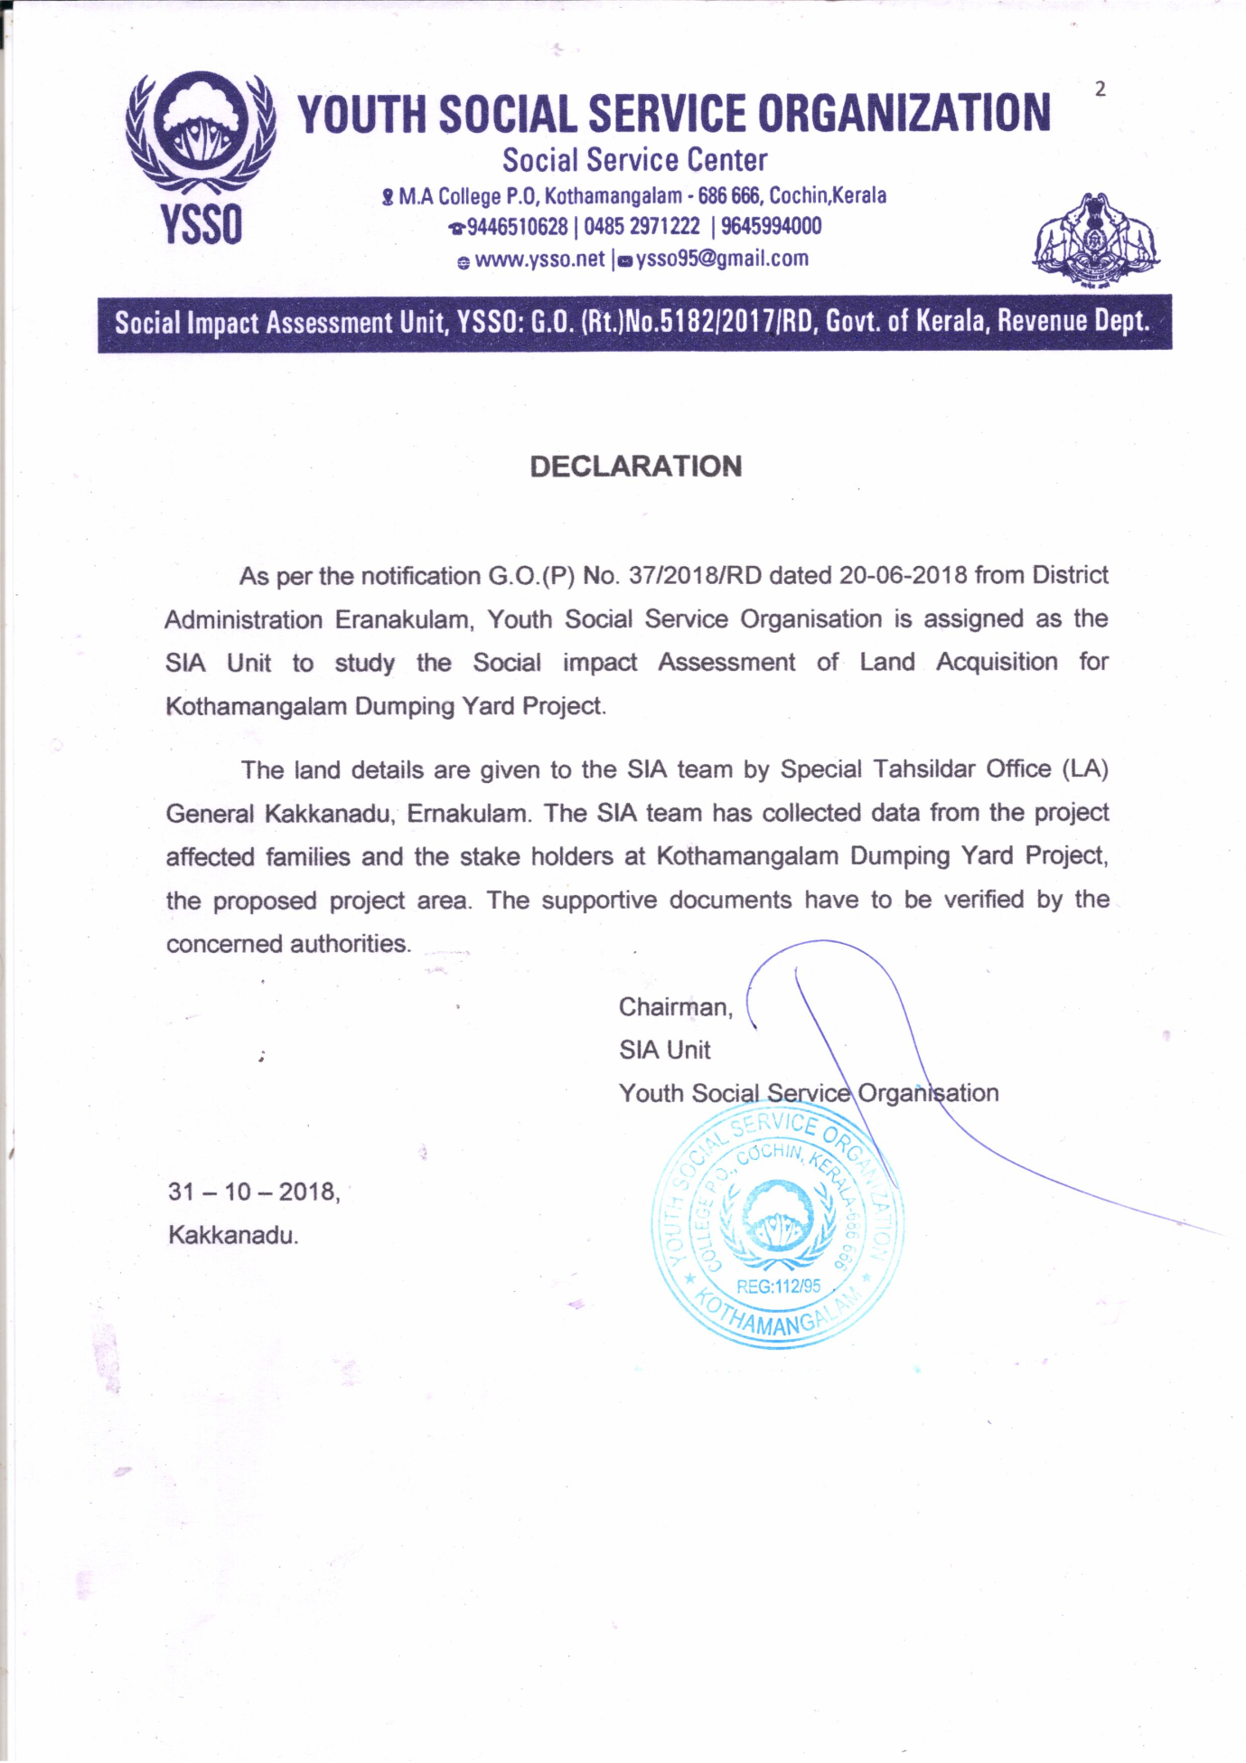

TABLE OF CONTENTS OF SOCIAL IMPACT ASSESSMENT REPORT SOCIAL IMPACT MITIGATION AND MANAGEMENT PLAN
FORM NO.6
[See Rule 15(5)]
Chapter | Contents
Executive summary | Preface: the project and public purpose
 | Location
 | size and attributes of land acquisition
 | proposed alternative for consideration
 | Social impacts
 | Mitigation measures
Detailed Project Description | Background of the project, Including developers background and governance/management structure
 | Rationale for project, including how the project fits the public purpose criteria listed in the act
 | Project size, location, production targets, costs
 | Examination of alternatives
 | Phase of project construction
 | Core design features and size and type of facilities
 | Need for ancillary infrastructural facilities
 | Work force requirements (temporary and permanent)
 | Details of environment impact assessment
 | Applicable law and policies
Study Team, Study Focus, Project Methodology Back Ground | Back Ground
 | List of all team members with qualification descripition and for the methodology and tools used to collect information for the social impact assessment
 | Sampling methodology used
 | Overview of information/data source used
 | Schedule of consultation with key stakeholders and brief description of public hearing conducted
Land assessment | Background
 | Describe with the help of the maps, information from land inventories and primary sources
 | Total land requirement for the project
 | Need of public property
 | Land already purchased, alienated, leased or acquired, and the intended use for each plot of land required for the project
 | Previous transactions in the project-area
Estimation And Enumeration | Preface
 | Family which are directly affected
 | Family of scheduled tribes and other traditional forest dwellers who have lost any of their forest rights.
 | Families which depend on common property resources which will be affected due to acquisition of land for their livelihood
 | Families which have been Assigned land by the State Government or the central Government under any of its schemes and such land is under acquisition
 | Families which have been Residing on any land in the urban areas for presiding three years or more prior to the acquisition of the land
 | Families which have depend on the land being acquired as a primary source of livelihood for three years prior to the acquisition
 | Period of ownership of Land
 | Inventory of productive assets
Socio- Economic Design | Introduction
 | Demographic details
 | Utilisation of land and livelihood
Social Impact Management Plan | Approaches to mitigation
 | Re-Establishment and Rehabilitation
 | Impact Mitigation and management plan
Social impact action plan directorate | Directorate and responsible officials
Social Impact Management Budget And Financing of Mitigation plan | Costs of all resettlement and rehabilitation costs
 | Annual budget and plan of action
 | Finding sources with break up
Social Impact Management Plan Monitoring And Evaluation | Key monitoring and evaluative indicators
 | Reporting mechanisms and monitoring roles
 | Plan of Independent evaluation
Analysis of costs and benefits recommendation on acquisition | Final conclusion and assessing the aims
 | Character of social impacts
 | Conclusion
 | Acknowledgement

LIST OF TABLES
Table 3.6 Scheduleof consultaions with key stakeholders
Table 4.2 land inventories (map of site)
Table 5.8 Duration of possession/ownership on property
Table 6.1 Age group and gender
Table 6.2 Religious group
Table 6.3 Marital status of the project affected persons
Table 6.4 Educational attainment of the project affected persons
Table 6.5 Occupational pattern and non working status of the project affected persons
Table 6.6 Affected people categorised by male and female
Table 6.7 Family monthly income

LIST OF ANNEXURES
Annexure 1 (a) Gazatte notification
Annexure 1(b) Draft notice copy
Annexure 1(c) Kothamangalam Dumping Yard Project alingnment sketch
Annexure 2 Socio economic survey questionnaire
Annexure 3 Public hearing notification news (mangalam, metro)
Annexure 4 Notice to the affected families
Annexure 5 List of participants-officials and affected families

CHAPTER -1
EXCUTIVE SUMMARY
  - Preface: The Project and Public Purpose
Kothamangalam, aptly known as the Gateway to the Highrange is a Municipal town situated at the extreme eastern end of Ernakulam district. The Municipality with an area of 40.04 square kilometre ranks sixth in the State in terms of size. As per the senses of 2011, the population is 38,822. Its geological pattern is of hills and valleys, and slants and plateaus. It is already a tourist area. The Municipality is comprised of 31 wards. The Cochi- Danushkodi National Highway and the Aluva – Munnar State Highway pass through the city. Being a sizeable Municipality, the roads are rather lengthy. It is one dependent on government grants for developmental projects as its own revenue is meager.
The site decided to set apart for the Dumping Yard is 2.4489 hectre land at Kothamangalam Village in Kothamangalam Taluk, Ernakulam District. Due to limitation of area, waste is heaped up now. Though at present there has been no problem as it is not a residential area popular protest is likely to crop up in future, if disposal is not done timely. Moreover there is every possibility for the waste to flow down to the road nearby during the rainy season. It is to solve such problems that a proposal has been made to take over the lands adjacent to the present site for the smooth running of the project. The lands to be acquired belong to private individuals.
Whilst facing opposition to such developmental projects due to their impact and to protect the interests of the affected that the RFCTLARR Act, 2013 comes to the rescue by guaranteeing fair compensation, transparent rehabilitation and re-establishment. Section-4 of the Act stipulates that public interests and social impact shall be assessed while taking over land for developmental projects in India.

1.2 Location
Kumpalathumuri area belonging to Kothamangalam Village, Kothamangalam taluk, Ernakulam District.
1.3 Size and Attributes of Land Acquisition
Proposed area is 2.4489 hectres. Non-residential area. Open ground owned by one person and source of income (Rubber Plantation) of another person.
1.4 Proposed Alternative for Consideration
Not applicable
1.5 Social Impact
Since the 2013 Act has been an integrated statutory guideline with regard to all forms of losses connected with land take-over, its legal implementation is adequate to compensate for the social impact
1.6 Break-down of Social Impact and mitigation steps
Sl.No. | Type of Impact | Current Condition | Proposed mitigation Steps
1 | Loss of land | Land impacted | Compensation as per RFCTLARR
2 | Loss of land | Non | Not applicable
3 | Loss of Useful property | Rubber | As per Act, 2013
4. | Loss of livelihood | Yes | “

CHAPTER -2
DETAILED PROJECT DESCRIPTION
2.1 Project and Popular goals
The site decided to be undertaken for the Dumping Yard is 2.4489 hectres of land at Kothamangalam Village, in Kothamangalam Taluk, Ernakulam District. The place is Kampathumuri, 3 km from the Municipal Office. The total area is 2 acres only. Due to limitation of space, presently only solid waste dumping is done here and the place is nearing completion. Majority of solid waste collection and transportation to the Yard have been done by Kudumbasri workers. Possible risk is that accumation will lead to overflow down to the nearby road. Being a non-residential area, there is no problem of protest at present. As the present site is inadequate by far for waste disposal, an amount of Rs. 1,70,00,000 has been budgeted to acquire the 2.4489 hectre
2.2 Project Size, Location, Production Targets and Costs
Kumpalathumuri area belonging to Kothamangalam Village, Kothamangalam taluk, Ernakulam District.
Proposed area is 2.4489 hectres. Non-residential area. Open ground owned by one person and source of income (Rubber Plantation) of another person.
2.3 Examination of Alternatives
Not applicable
2.4 Phases of The Project Construction
Not applicable
2.5 Need for Ancilliary Infrastructural Facilities
Not applicable

2.6 Work Force Requirements
Not applicable
2.7 Details of Environment Impact
Not applicable.
2.8 Applicable Rules and Statutes
- Rights Act (Central Government.) for fair compensation, transparency, rehabilitation and re establishment for land acquisition.
- The policy of the Revenue Dept; Kerala Government with regard to compensation and transparency in land acquisition.
- Right to Information Act 2005

CHAPTER -3
STUDY TEAM, STUDY FOCUS, PROJECT METHODOLOGY BACK GROUND
3.1 Background
Youth Social Service Organization has been appointed to conduct a study to assess the social impact caused by the Kothamangalam Dumping Yard building activities as per G.O. (P) No. 37/2018/RD notified by Ernakulam District Administration dated 20.6.2018.
The goal of the study is to enumerate the persons, assess the impact and finally prepare a counter impact plan for the affected area.
For the aforesaid purpose, information was collected respectively from primary and secondary sources. As part of the Assessment of the project impacted area, a socio-economic survey was also made by the experienced members of the Unit.
3.2 List of all team members with qualifications description and rationale for the methodology and tools used to collect information for the social impact assessment
Data collection and co-ordination for the social impact assessment were done by an eight – Member – study team who have had a wealth of experience in similar field under the leadership of the Head of the Assessment Unit, the Executive Director of Youth Social Service Organization. Services of experts in the field of development/Law had also been borrowed for the study and preparing the reports. Besides, in order to identify the impacted areas, help of the officials of the Revenue Dept. Was as well sought.
Sl. No. | Name | Position, Qualification, Experience
1. | Shaiby Jose | Team Leader, M.B.A. 10 years work experience in Development field
2. | Kuriakose George | Project co-ordinator – L.L.B. 15 years in Development field
3. | Baiju P.T. | Research Associate – M.S.W. 10 years in Development field
4. | P.C. Jose | Research Associate – M.S.W. 10 years in Development field.
5. | Sholey | Research Associate – M.S.W. 5 years in Development field.
6. | Nithin P.S. | Research Associate – M.S.W. 1 year in Development field.

If the evacuation has caused any physical or financial problems to the people, such are to be assessed and the necessary rehabilitation or compensation measures are to be taken. If the loss is related to livelihood, adequate compensation no less has to be included in the re-establishment plan. The Study Team should essentially consider the following while preparing the implementation plan: - (1) awareness of the socio-economic impact of the Project (2) awareness of the legal matters related to acquisition and compensation
Details of the social Impact Assessment, the study Approach and the Project Science are given in Fig. 3.1 in a Flow-chart form.
Figure Social Impact Study Pattern and Methods
Phase -1
Activities prior to the survey
Literature Survey and Primary meeting | Primary Survey and Start of Out-door work
- Detailed Plan Survey  - Preparation of Plan Design  - RFCT in LARR Act, 2013  - State Law related to Land acquisition | - Primary Study  - Preparation and inspection of Survey tools  - Finding teams for information collection  - Finalisation of Primary Report

Phase -2
Data collection method and execution set-up
Project Impacted Families/People/ Community | Arrangements for Project implementation
- Training for the field staff  - Data collected from the impacted families  - Discussions with the officials of the respective departments | - Analysis of the legal policies and regulations  - Discussion with the local officials regarding rehabilitation plan.  - Analysis of the data  - Draft report on data collection, analysis and impact assessment

Phase -3
Post Survey Activities and Analytical Plan
Tabulation of Data and Analytical Plan | Discussions on social impact assessment Report
- Unification, editing and documenting of data  - Finalisation of assessment report  - Draft report preparation and submission of impact assessment report | - Organising Public hearing  - Discussing assessment finding with the impacted parties.  - Reporting their concerns with the respective persons.  - Analysis and opinions of the respective officials  - Unification of opinions and finalisation of impact report.

3.3 Sampling methodology used
Data from secondary sources were compiled with those collected from previous studies and the concerned departments. Through the survey conducted in the Project-area, information on the affected parties could be collected and the physical, social, economic and cultural status of the community could be learned.
3.4 Overview for Information/Data Sources Used
Prior to detailed study of social impact assessment, visit to the socio-economic Survey area and initial study were done. In addition, direct talks were made with the affected parties and their reactions were recorded. The team made necessary additions and corrections in the interview – schedules.
On 20/07/2018, the team visited the project area and clearly noted the sites included in the Project plan. Thereafter, they talked to the people and held a meeting to create awareness about the Project. The team collected information during July 2018
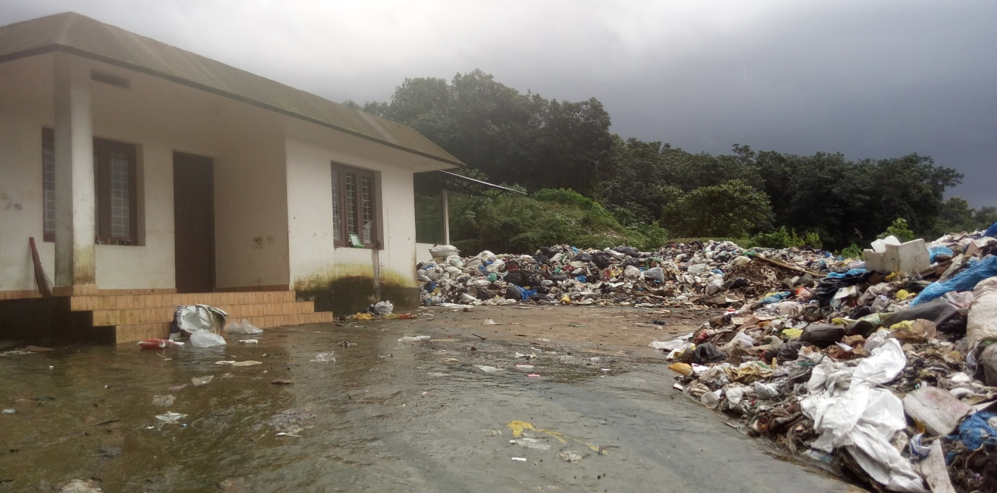
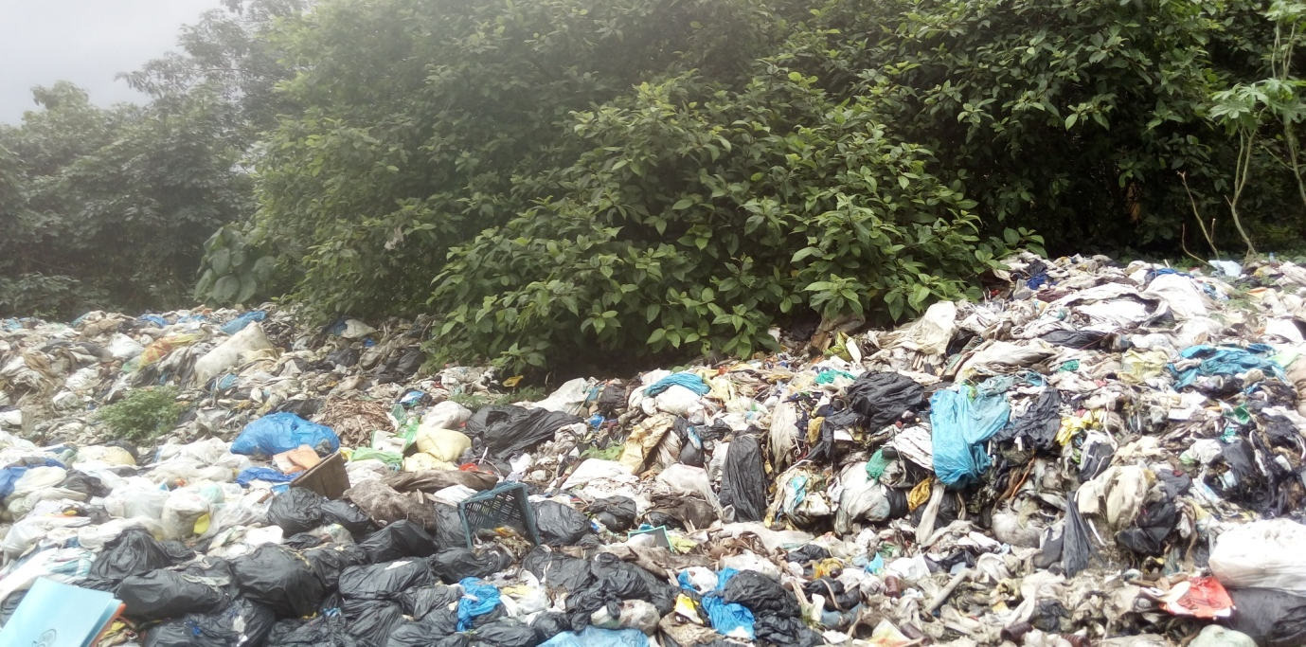
3.5 Socio – economic survey
Even before starting the socio-economic Survey, information was availed, regarding the impacted areas from the alignment drawing with the help of the officials of the Revenue Dept. The survey was by means of direct interviews with the affected parties. Details about the impacted land’s size, type etc were revealed in the interviews. The genuinity of such information was verified and reaffirmed by means of legal documents. The data collected thus were details of the impacted families, their legal documents, social information, self-employment details, types of employment, etc. The Questionnaire contained pre-coded questions as well as open-ended questions to include their free-willed opinions. Prior to filling –up the Questionnaire, it was ensured by checking the available and necessary documents that they were bona fide residents of the affected areas.
3.6 Data checking and compiling
The data in the filled –up Survey Forms were fed to the Database; those columns unfilled due to uncertainity were filled up after checking the necessary documents and added to the data base.
3.7 Data analysis and report preparation
Data were checked after scientific analysis and report was prepared.
3.8 Discussion with community and the public
Discussions were held with the directly impacted and sought their opinions and suggestions with regard to ways and means to mitigate the adverse affects of the project. In order to gather information, media such as informal talks, private meetings, serious personal interviews etc. were made use of
3.9 Schedule of consultations with key stake holders and brief description of public herarings conducted
Those belonging to Kothamangalam Village, Kothamangalam Taluk
Sl.No. | Name and address of person/Family | Survey No. | Situation as Explained | Problem/Need Raised | Reply by concerned authorities
1. | Jude Joseph, Perumpillichy, Onnammile, Kothamangalam 686 666 | 959/1m /2/2 | - | The land affected by the project is the plain land belonging to him. The consent letter for land surrender was provided before one and half years. No action is taken yet upon the same. Now not satisfied with the agreed price. Looking for justified compensation against the delay in execution. | Eligible for compensation as per rules, for land acquisition, for transparency, for rehabilitation and re-insation.
2. | Bharathan / Prasanna Ashtapathy house,  Powathil Road, Ayyappankavu | 959/1m/2/2 |  | The land affected by the project is where this family cultivates Rubber trees for their livelihood. They have also given the consent letter for land surrender before one and half years.As there is no decision yet, they are now not satisfied with the amount in the consent letter. This land is under the names of two persons. Looking for justified compensation in an all inclusive manner. | Eligible for compensation as per rules, for land acquisition, for transparency, for rehabilitation and re-instation.

3.10 Brief description of the public hearing conducted
Regarding the land acquisition for the Kothamangalam Dumping yard project, a public hearing was conducted on October 10th 2018 at the Municipal hall, Kothamangalmwith the land owners of survey number 959/1M/2/2 and authorities of Kothamangalamtaluk, Kothamangalam village.
From L.A. office Special Tahsildar L.A. General (Kakkanad) Mr. Joseph K.O, Revenue Inspector Mrs. B. Sujatha, LDC Mrs. Anjali P.R., Surveyor Mr. Prvaveen Kumar P.R., Mr. G. Sunil (FGAS) and Valuation Assistant MR. Ranjith George have attended the meeting.
Deputy Tahsildar Mr. Unnikrishnan from KothamangalamTaluk office, Mr. Shanavas K. Aziz (V.A.) from Kothamangalam Village office, Mrs. Kavitha S. Kumar from Kothamangalam Municipality, Vice ChairmanMr. George, Plan Clerk Mr. Byju M.D.and Councilor Mrs. Helen Titus have also attended the meeting. Also the land owners Mr. Jude, Mr. Bharathan, Mrs. PrasannaBharathan and the members of Youth Social Service Study group have attended the meeting.
The land owners attending the public hearing raised their issues in front of the concerned authorities. Report was presented by Mrs. SavithaSajeesh, member of the Youth Social Service Study group. The land for the project is included in the survey no. 959/1M/2/2 of Kothamangalam Village. It was agreed to surrender the land before one and half years. This is the only land owned by the above mentioned people. Proper compensation due to the delay in execution was requested to the concerned authorities. For another person, the project land is the rubber cultivation which is the only livelihood for his family. This is the only property in his name and the same is under his wife’s name also. Consent letter was given before one and half years. They are not satisfied with the amount provided. They have requested the concerned authorities for justified compensation.
It was informed by the Special Tahsildar (L.A) that the public hearing will be recorded as per the L.A. act and the report by S.I.A. will be given to the Collector on which the Collector will be taking the final decision after the expert committee. It was explained that 12 title deeds in an area of 5 Km will be examined and out of those 6 deeds will be selected to find the average and the highest price and the compensation is decided based on the fair value taken. The Special Tahsildar (L.A.) affirmed that all the benefits of the law will be available to the parties. He had emphasized on the support by the land owners for the progress of the project.
It was informed by the Vice Chairman that the land owners are not satisfied by the compensation offered as per the former consent letter and the Municipality does not have assets and hence cannot increase the compensation amount. He also informed that the Municipality is running short of funds and got liabilities to pay off. He had mentioned that waste management is a very important requirement for the people and the land owners have to cooperate to complete the construction of the Dumping Yard at the earliest. To this the Vice Chairman added that if the land owners are proceeding with their request for additional compensation, the whole project itself shall be called off by the Municipality.
The parties have informed that the decision by the land lords shall be conveyed to the Municipality.
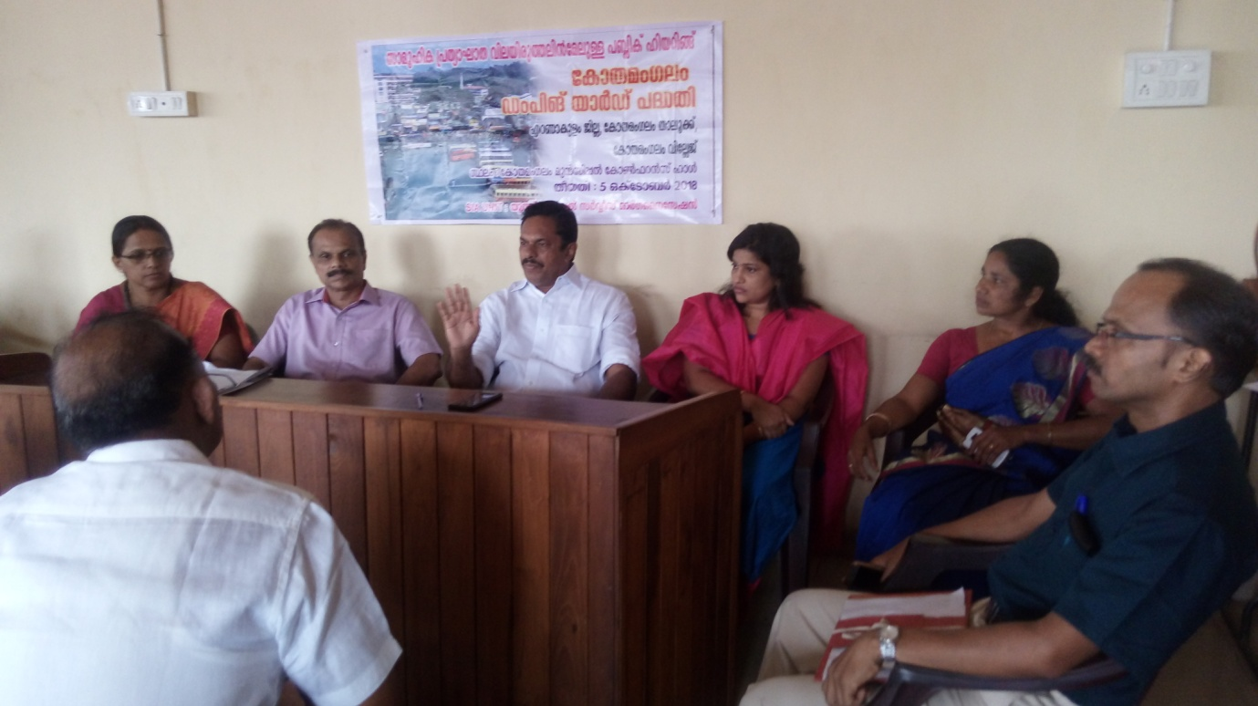
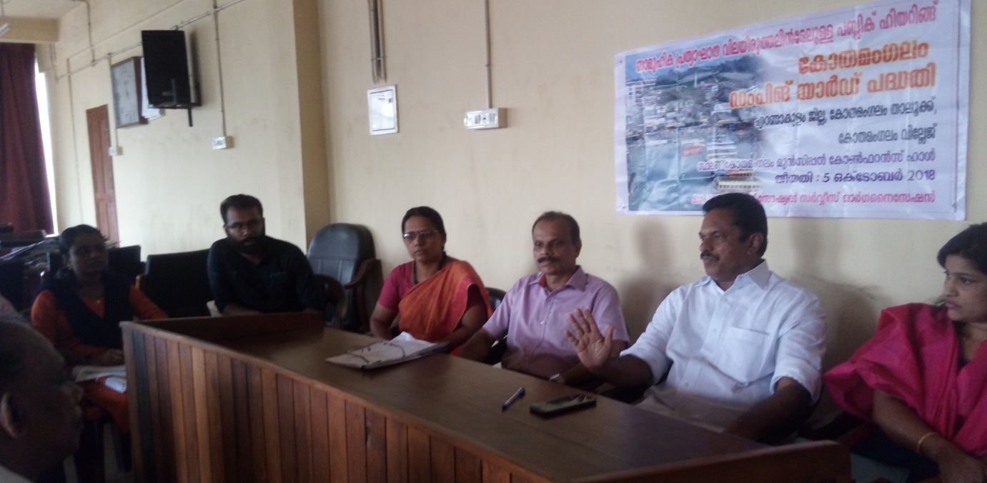

CHAPTER -4
LAND ASSESSMENT
Background
SIA unit conducted a socio-economic survey of the Project site in July, 2018 involving the project impacted families. Information regarding the income of the persons and their livelihood and how deeply the project would affect such matters could be collected through the survey. A pre-prepared Questionnaire was used for the purpose. The goal of the survey was to assess the socio-economic structure of the families, the types of the properties, right to the property, the nature of probable impact and details of the depth of the impact on property. The major findings and the gravity of the problem are given below:-
4.2 Describe with the help of the maps, information from land inventories and primary sources.
The area acquired for the Project is 2.4489 hectre land belonging to Survey No. 959/1m/2/2 of Kothamangalam Village, Kothamangalam Taluk, Ernakulam District. The said land is owned by 2 persons. Of this one part is empty ground and the other is a Rubber plantation.

Inventories (map of site)
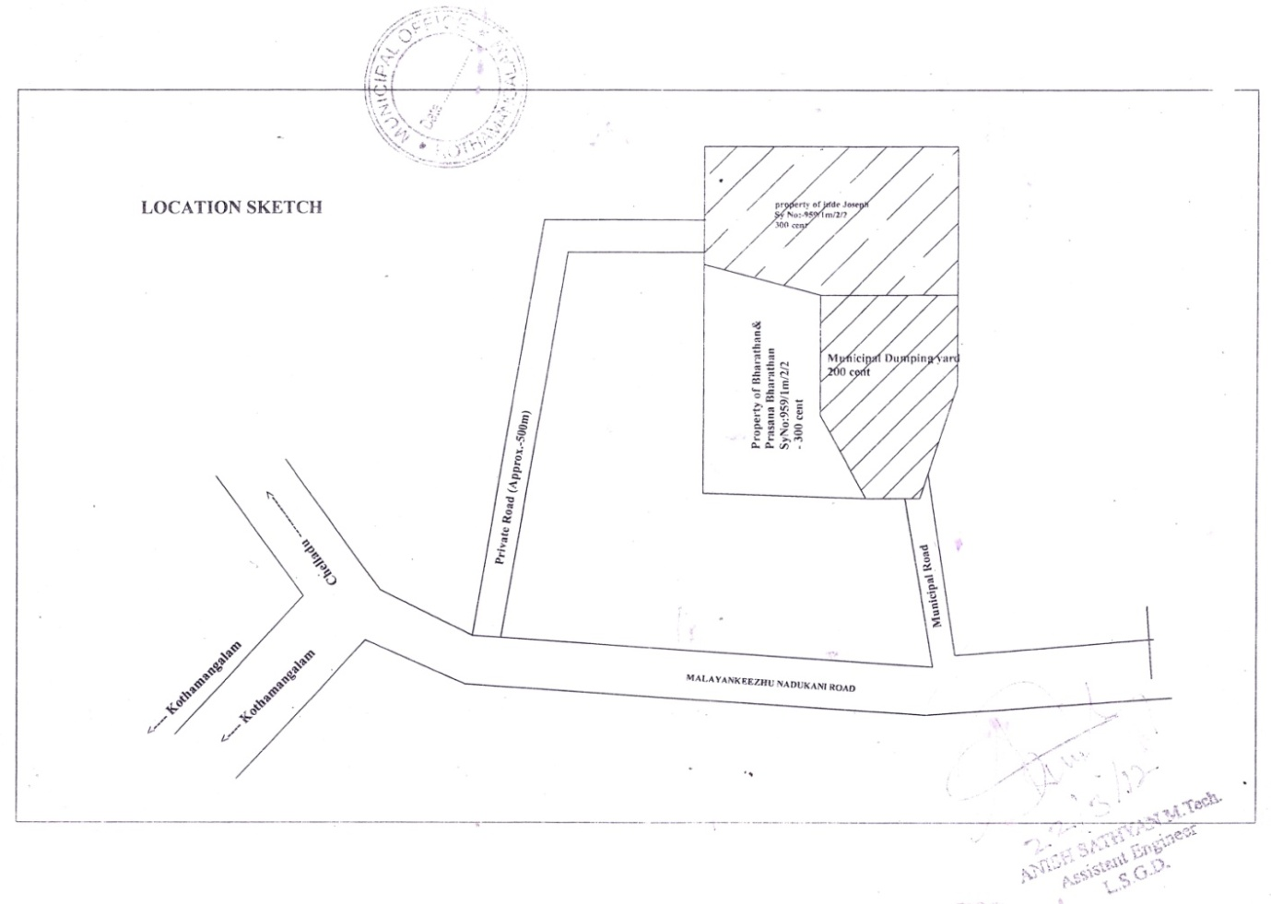4.3 Total land requirement for project
Proposed area is 2.4489 hectres. Non-residential area. Open ground owned by one person and source of income (Rubber Plantation) of another person
4.4 Need of public property
Public place has not been affected by the project.
4.5 Land already purchased,alienated, leased or acquired,and the intended use for each plot of land required for the project
Not applicable
4.6 Previous transactions in the project – area
No transaction has been done for the area for the last 3 years as per information from the data collectors.

CHAPTER -5
ESTIMATION AND ENUMERATION
5.1 Preface
This chapter deals with the assessment of the properties that the families are losing directly and indirectly while implementing the Project and their appraisal.
5.2 Those directly impacted by the Project
Of the impacted area, one part is an open ground and the other is cultivated land.
5.3 The indirect impact
With the loss of farmland, one person is bereft of his livelihood. No family loss is involved.
5.4. Family of scheduled tribes and other traditional forest dwellers who have lost any of their forest rights
Not Applicable
5.5 Families which depend on common property resources which will be affected due to acquisition of land for their livelihood
Not applicable
5.6 Families which have been assigned land by the state Government or the central Government under any of its schemes and such land is under acquisition
Not applicable
5.7 Families which have been residing on any land in the urban areas for presending three years or more prior to the acquisition of the land
Not applicable
5.8 Families which have depend on the land being acquired as a primary source of livelihood for three years prior to the acquisition
One families are depending upon projected areas
Affected families
5.9 During Of Possession/Ownership On Property
Serial No. | Survey No. | Period of Ownership
1. | 959/Im/2/2 | 27 years
2. | 959/Im/2/2 | 18 years

5.10 Details of Yielding properties
The impacted land is 3 Acre Rubber farmland. Loss of income from Rubber production.

CHAPTER -6
SOCIAL, CULTURAL AND ECONOMICAL DETAILS
6.1 Intoduction
This chapter comprises the social, economic and cultural conditions of the affected families and their peculiarities. It also contains details of the population, the weaker section in the society, economic activities, means of livelihood, socialisation and related information.
6.2 Demographic details
See Pic6. 1 Age Category
Age | Number | Percentage
11-20 | 2 | 25
21 – 30 | 2 | 25
31 -40 | 0 | 0
41 – 50 | 1 | 12.5
51-60 | 3 | 37.5
61 – 70 | 0 | 0
Total | 8 | 100
Table 6.2 Religious Classification
Religion | Number of Families | Percentage
Muslim | 0 | 0
Christian | 1 | 50
Hindu | 1 | 50
Total | 2 | 100

Table 6.3 Marital Status of Project Affected Persons
Marital Status | Number of Persons | Percentage
Married | 4 | 50
Unmarried | 4 | 50
Widower/Widow | 0 | 0
Total | 8 | 100

50% are married and 50% are unmarried
Table 6.4 Educational Attainment of Project Affected Persons
Educational Status | Number of Persons | Percentage
Primary Education | 1 | 12.5
Plus -2 | 3 | 37.5
Graduates | 2 | 25
Post-graduates | 2 | 25
Unlettered | 0 | 0
Total | 8 | 100

Table 6.5 Occupation Details
Field | Number of Family | Percentage
Labourer | 0 | 0
Private Sector Work | 0 | 0
Agriculture | 1 | 12.5
Business | 1 | 12.5
Dependants | 6 | 75
Total | 8 | 100

Working persons in the impacted area are 2 only, the rest are dependants family
6.2 Income and economic category
The impacted families are Above Poverty Line as per Public Distribution System.
6.6 Family Income (monthly)
Monthly Family Income | No. | Percentage
Upto Rs. 5000 | 1 | 50%
5001 – 10,000 | 1 | 50
Total | 2 | 100

Monthly income is less than 10,000
6.3 Use of land and livelihood
Part of the affected land is empty ground owned by one individual and the other part is Rubber plantation which is the source of livelihood of another person.

CHAPTER –7
COUNTER – IMPACT
IMPLEMENTATION PLAN
7.1 Impact mitigation approach
The Counter – Social impact Implementation Plan has been designed to reduce the adverse effects that can happen when land is taken-over for the project. The demand of the affected people is commonly satisfactory compensation amount. Hence it has been proposed as the counter – impact step to arrive at an agreement with the affected parties after discussion and dispense the amount prior to the land acquisition.
Compensation for trees and other immovable properties
Deserving compensation shall be included in the rehabilitation package for the trees and other immovable properties that are existing in the plot taken over.
7.2 Guideline to negate, mitigate or compensate for the impact
To pay compensation on time as per the Rights Act, 2013, that stipulates fair compensation for transparency, rehabilitation and re-establishment related to land acquisition.

CHAPTER –8
COUNTER – IMPACT PROJECT ESTABLISHMENT
8.1 Set-up and responsible persons
As per the stipulation of Rights Act, 2013, the responsibility for devising the rehabilitation and establishment welfare scheme for the impacted families, shall rest with the Administrator appointed by the Govt. The Administrator, under the overseeing guidance and control of the commissioner and the Govt. shall be responsible for the implementation and supervision of the rehabilitation scheme.
The impact of the proposed project can be mitigated by paying compensation as per Act, 2013.
` As per the Policy formulated by the Govt. of Kerala, vide G.O. (M.S) No. 485/2015/RD, for land acquisition, and payment of compensation, the following officials shall be included in the District Committee to be constituted for the purpose.
- District Collector
- Administrator for Rehabilitation and re-establishment
- Land acquisition Officer
- Finance Officer
- Representatives of Finance authorities to take financial decisions.
- Representatives of Local Self-rule Dept. Who will monitor the rehabilitation plan.

CHAPTER – 9
SOCIAL IMPACT MANAGEMENT BUDGET AND FINANCING OF MITIGATION PLAN
9.1 Costs of all Resettlement and Rehabilitation Process
Not Applicable
9.2 Annual Budget and Plan of Action
Not Applicable
9.3 Funding sources with break up
Not Applicable

CHAPTER – 10
SOCIAL IMPACT MANAGEMENT PLAN MONITORING AND EVALUATION
10.1 Key monitoring and evaluative indicators
Not applicable
10.2 Reporting mechanisms and monitoring roles
Not applicable
10.3 Plan of independent evaluation
Not applicable

CHAPTER – 11
ANALYSIS OF COSTS AND BENEFITS RECOMMENDATION ON ACQUISITION
11: 1 Final conclusion and assessing the aims
In fact, the Kothamangalam Dumping Yard Project is setting the main backup facilities to expedite future growth. Open ground owned by one person and source of income (Rubber Plantation) of another person.
11.2 Character of social impacts
Whilst facing opposition to such developmental projects due to their impact and to protect the interests of the affected that the RFCTLARR Act, 2013 comes to the rescue by guaranteeing fair compensation, transparent rehabilitation and
re-establishment. Section-4 of the Act stipulates that public interests and social impact shall be assessed while taking over land for developmental projects in India.

CONCLUSION
In fact, the Kothamangalam Dumping Yard Project is setting the main backup facilities to expedite future growth. The Kothamangalam Dumping Yard Project is engaged in construction activities foreseeing the increased demand for Waste Management Plant.
With the loss of farmland, one person is bereft of his livelihood. No family loss is involved. The consent letter for land surrender was provided before one and half years. No action is taken yet upon the same. Now not satisfied with the agreed price. Looking for justified compensation against the delay in execution.
In view of the benefits that the Kothamangalam Dumping Yard brings about for the people, land acquisition was inevitable. It has to be borne in mind that the fairest solution to such undertaking is compensating the affected in a just and legitimate manner.

ACKNOWLEDGEMENT
This study would not have been completed without the unlimited co-operation of several individuals and organisations. First of all, let us record our deep gratitude towards to authorities of the Revenue Dept. For having entrusted the task with the Youth Social Service Organization. We cherish with thanks the services of the Hon. District Collector and Member of the Staff who have rendered the required guidelines and support for the team in order for us to complete the Study Successfully
We express our deep thanks to How. Special Tahsildar (L.A.) General, Kakkanadu and the Staff for the vital information and technical advice related to land acquisition.
We would as well thank each and every Member of the staff of Kothamangalam Municipalilty for all the support. We are indebted to all the citizens of the project locality for their co-operation and assistance.
The Executive Director of Youth Service Organization has served us all through the mission as the leading source of inspiration without the full and sincere support of each and every good soul cited above, this study would not ever have been fulfilled flamlessly.

ANNEXURES
Annexure 1 (a) Gazatte notification
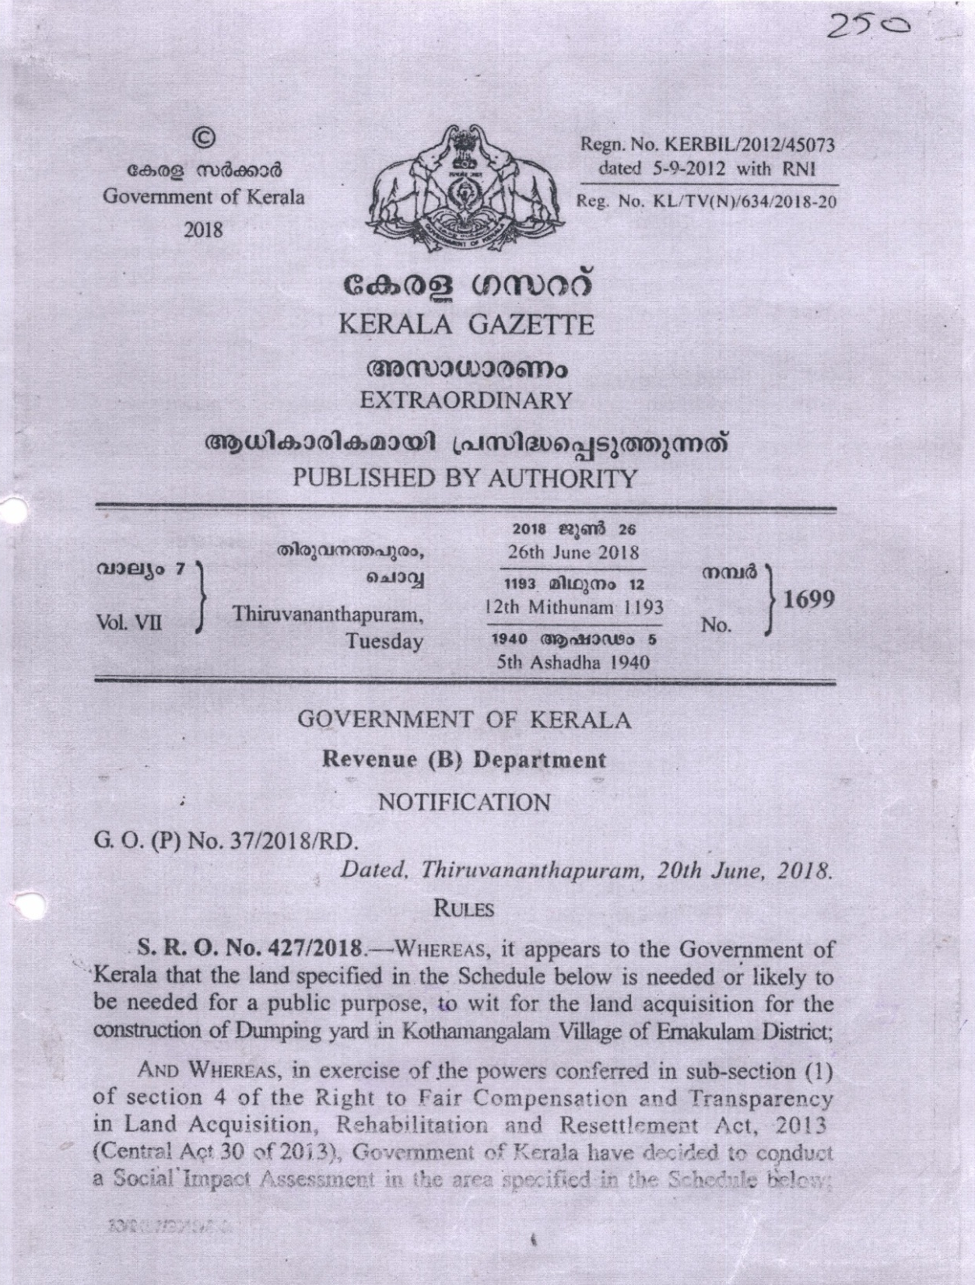

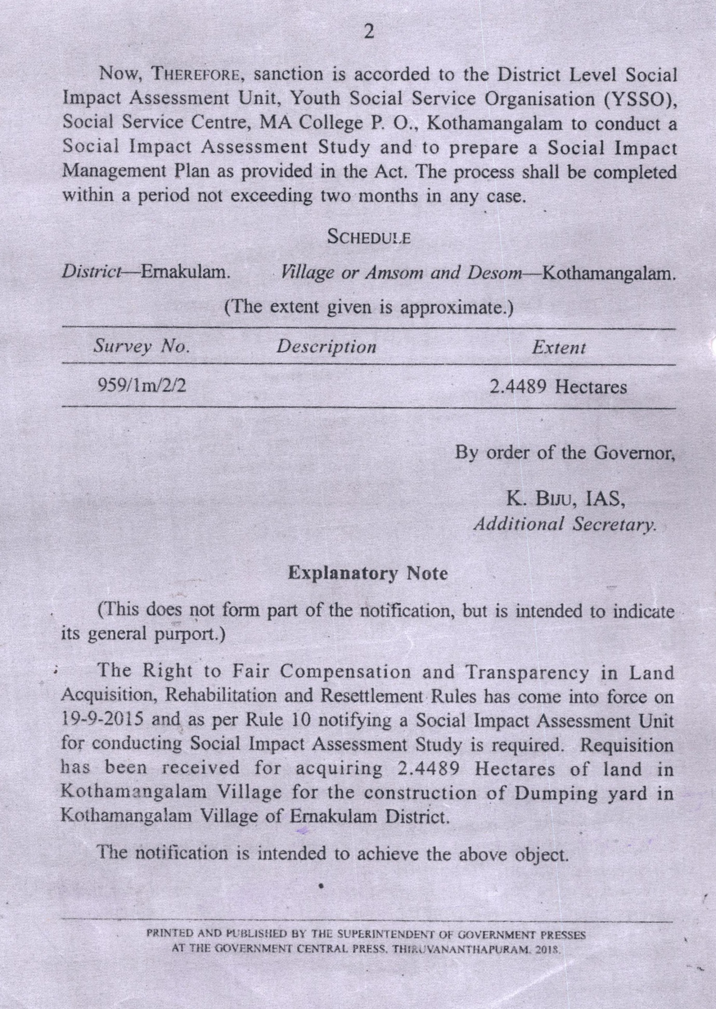

Annexure 1(b) Draft notice copy
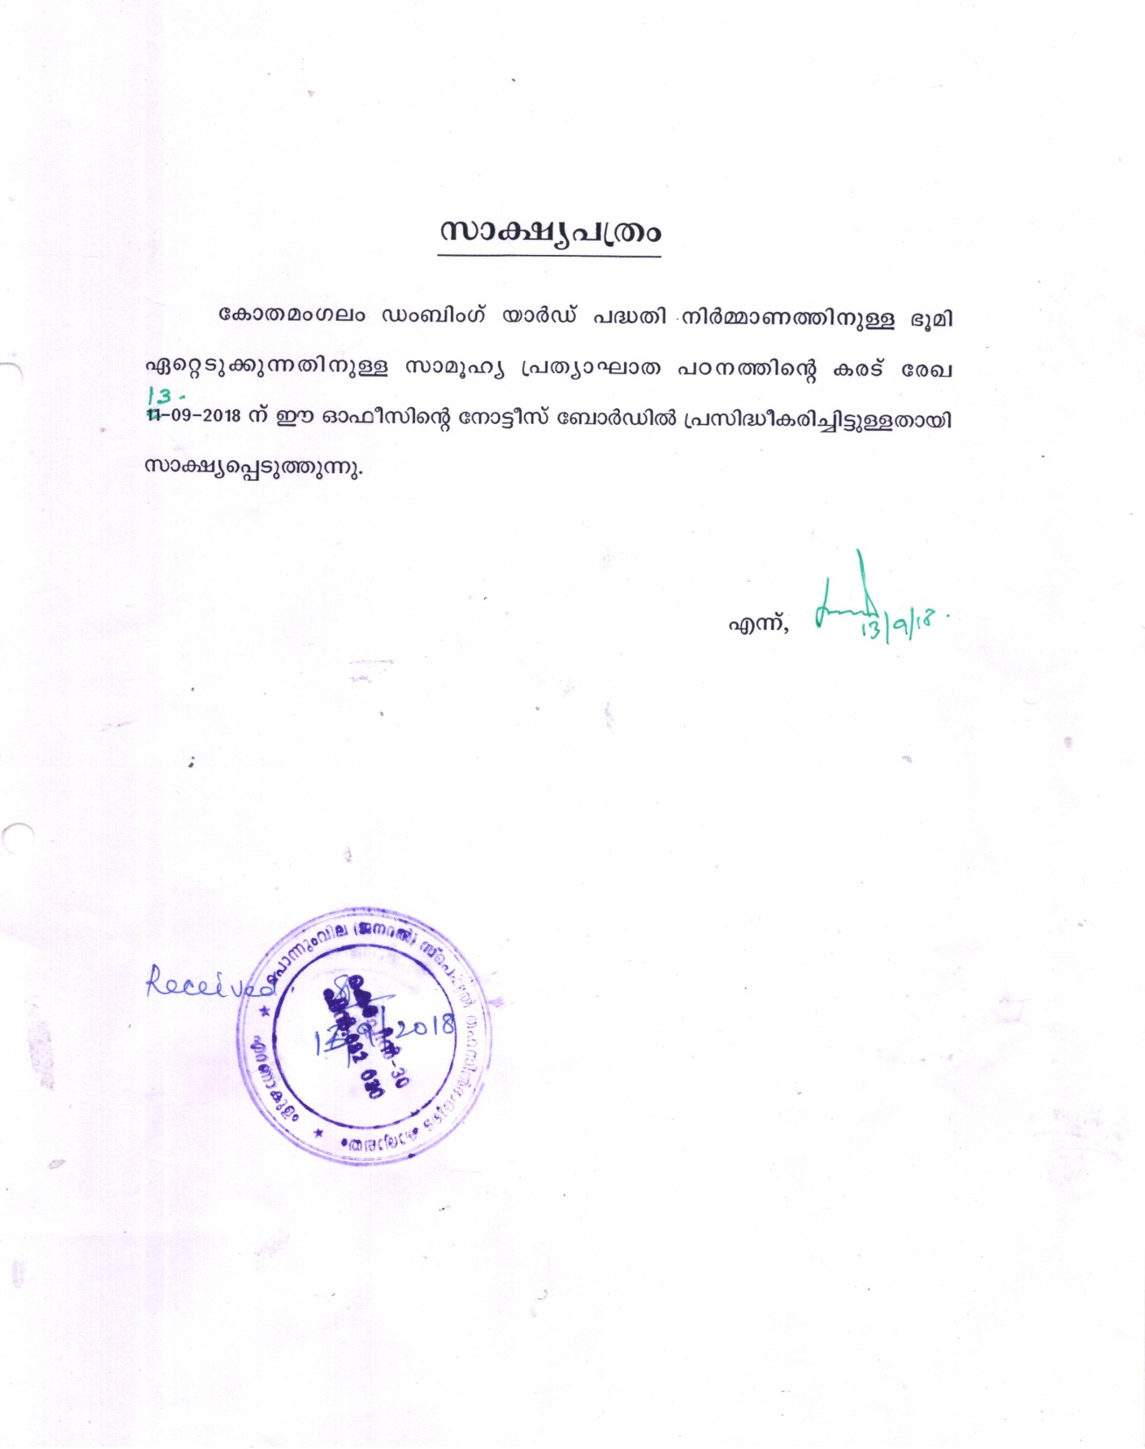

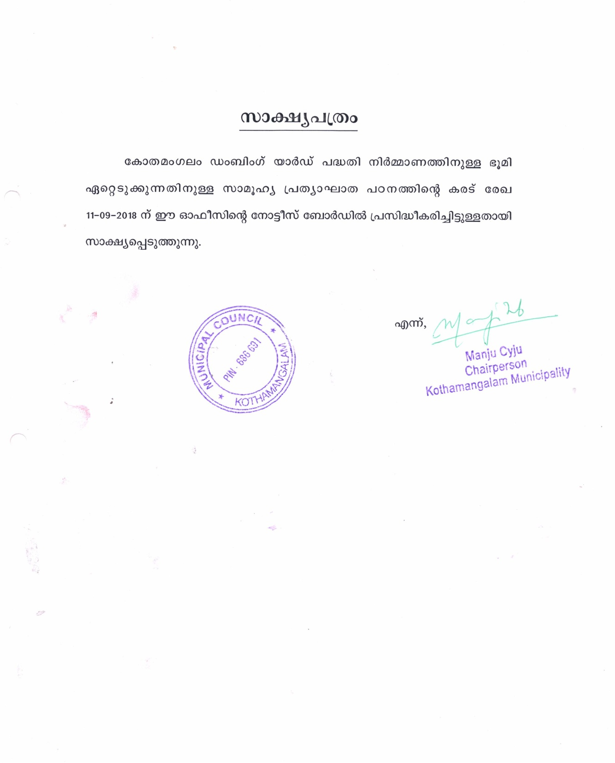

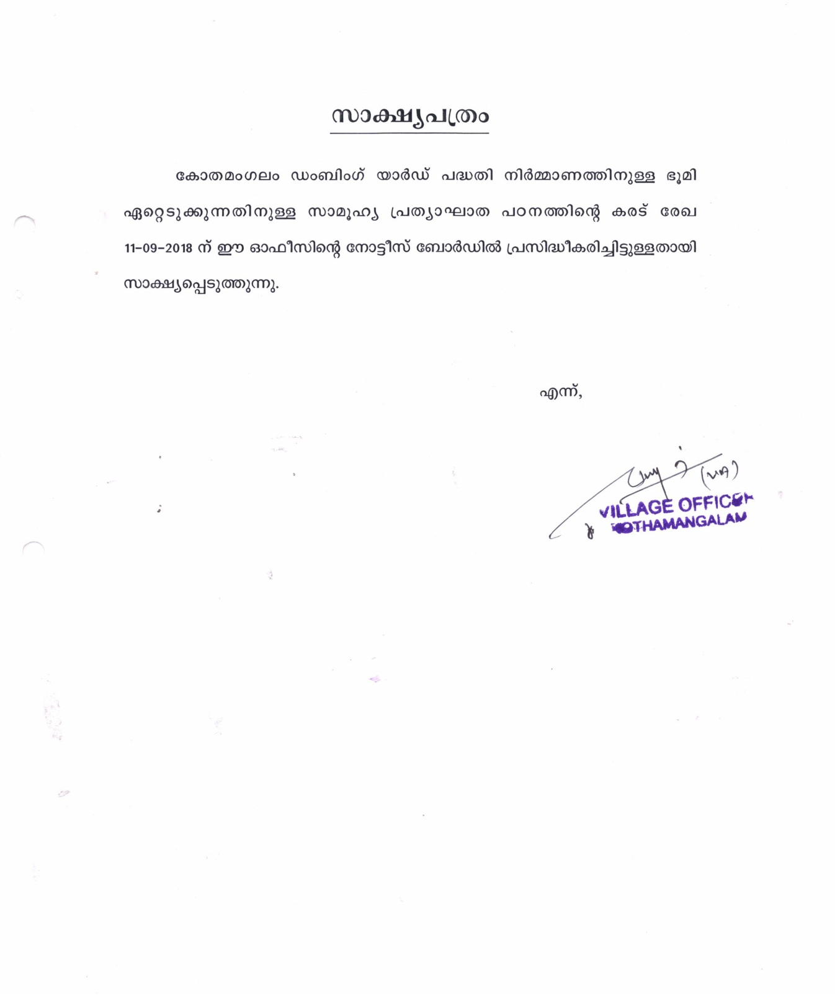

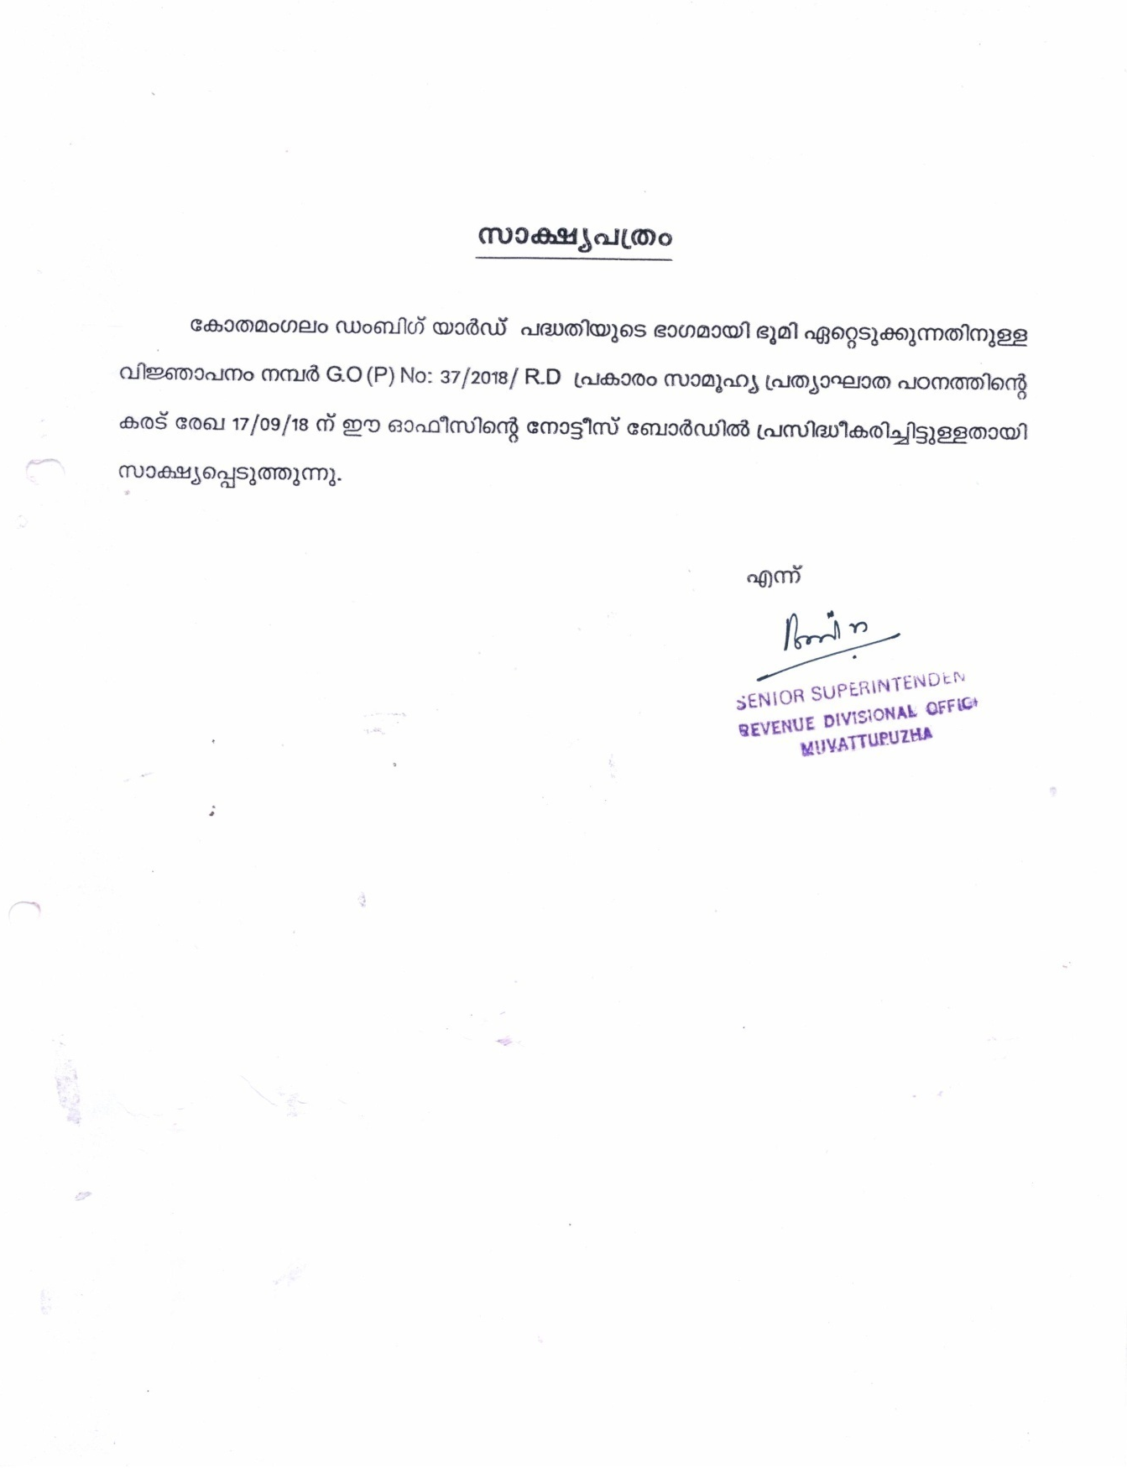

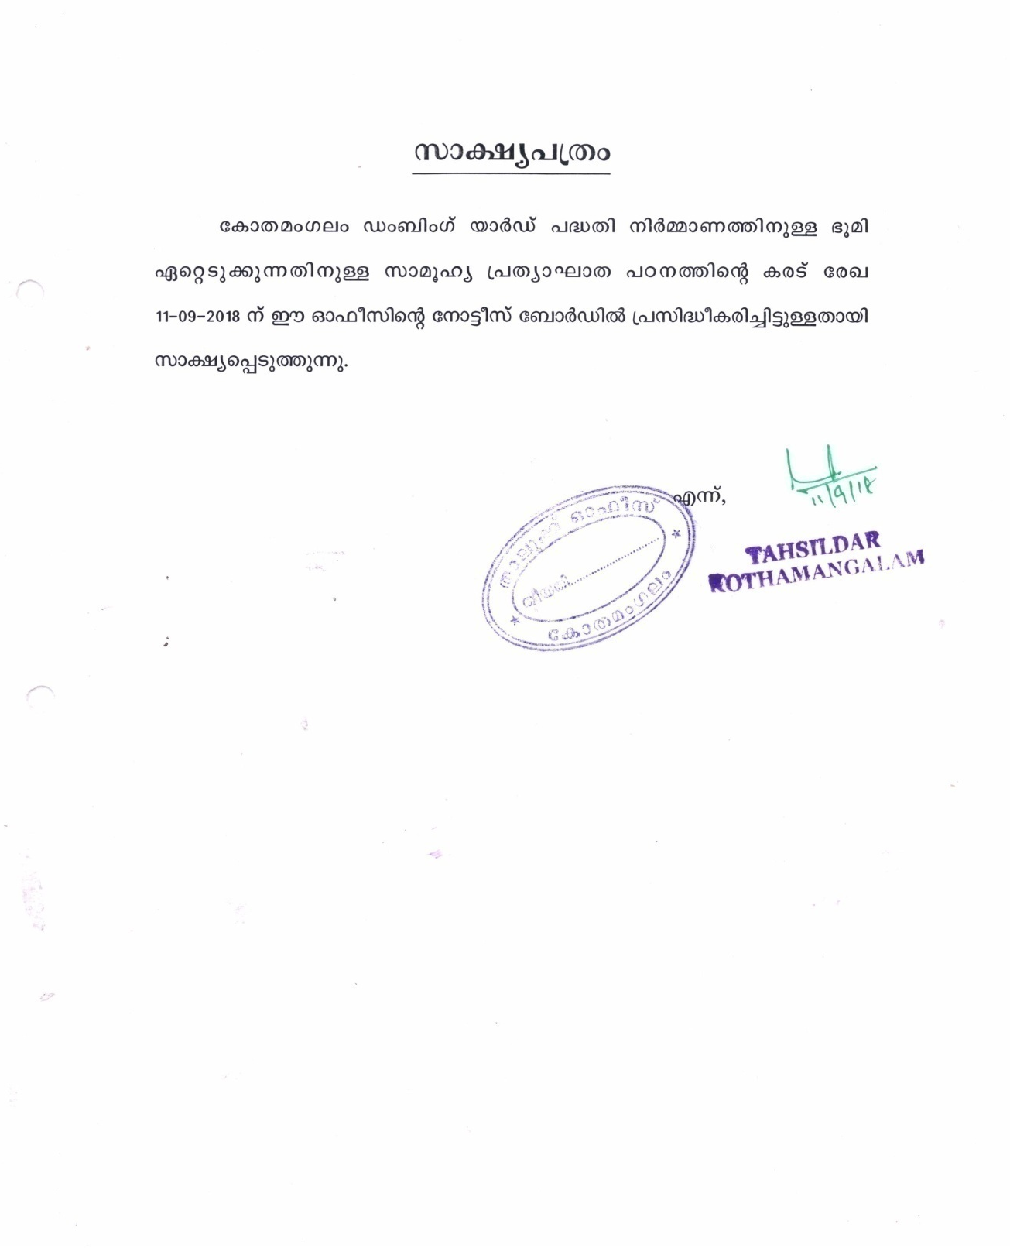

Annexure 1(c) Kothamangalam Dumping Yard Project alingnment sketch
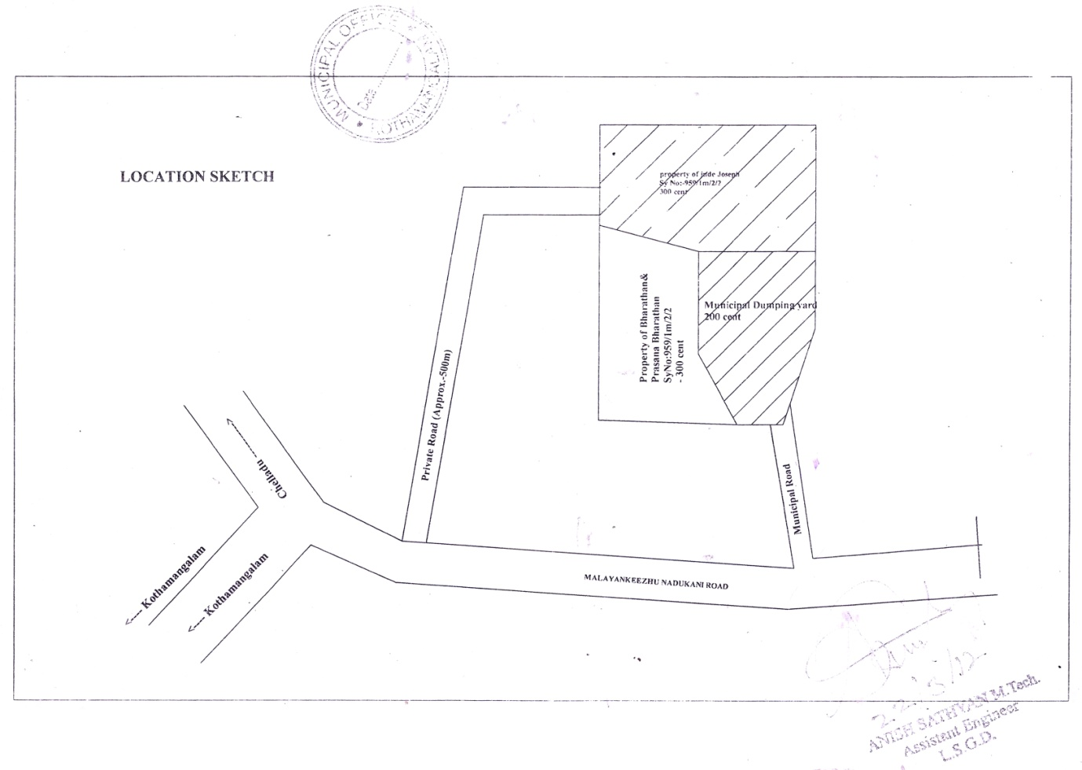

Annexure 2 Socio economic survey questionnaire
Socio Economic Survey for Social Impact Assessment Study
Land Acquisition for Kothamangalam Dumbing Yard Project
SIA Ref No
Interviewer’s Name
Survey Date
Supervisor Name
Data Entry Staff Name
Date Entered Date
Data verified by and Date

Respondent’s Name
Name of the affected person (if different from above)
Address including PINCODE (Location in the Affected Area)
Contact (Landline No.)
Contact (Mobile No)
Identity Card Details (any one id proof)
Aadhaar No.
Ration Card No.
Passport No.
Voters Id

Q.1 Identification | Place/Location
 | Ward No.
 | Name of Panchayath
Q. 2 Respondent | Owner |  |  | Representative of Owner

Q. 3 Name & Address of the Respondent | Owner |  | Representative of Owner

ASSET DETAILS
Q. 4 Type of Property
Open Land |  | Nilam |  | Nilam Nikathu Purayidam

Q. 5 Type of use
Open Land |  | Wet Land (Agricultural Land) |  | Others (specify)

Q. 6 Name of title holder of the property
(Specify the names of all the members specified as per the title deed)
- Communication Address (with PINCODE)
- Contact No
- Relationship with family head
- Acquisition by | Hereditary
 | Purchase
 | Encroached/squatter
 | Others (specify)
- Date of acquiring of the property (approx period)
- Details of transactions made on the property within the last three years
Q. 7 Property Details
a) Survey No (Mandatory
b) Total Area (in hectares)
c) Area Affected (in hectares)
In case of more than one property please use additional pages
IMPACT
Q.8 Extent of acquisition | Fully |  | Partially
Q. 9 Whether property viable after implementation of project | Yes |  | No
Q. VULNERABILITY
Q. 10 Do you have Ration Card? | Yes |  | No |  | If Yes, Mention Number
Q. 11 Type of Ration Care | BPL |  | APL |  | AAY

GENERAL INFORMATION
Q. 12 Size of Family/household (specify no of family members) | Male | Female

Family Pattern | Joint |  | Nuclear |  | Individual

Q. 13 Religious | Hindu |  | Muslim |  | Christian |  | Jain |  | Others
Q. 14 Social Group | SC |  | ST |  | OBC |  | General |  | Others

FAMILY MEMBERS – DETAILS
SL. No. | Name | Relation-ship with the Head of the family | Age | Sex | Marital Status | Education |  | Job | Monthly Income | Major diseases
 |  |  |  |  |  | Completed | Continuing

Q. 15 Livelihood (Major Source of Income) of Family affected | Yes |  | No
Q. 16 Family Income & Source
a) Family monthly income (in Rs.)
b) Family monthly expenditure (in Rs.)
c) Major Source of Income
c) No of adult earning members
d) No of depenents
Project Related Information
Q. 17. Are you aware of the proposed Kothamangalam Dumbing yard Project | Yes |  | No

Q. 18 If yes, source of information
Newspaper |  | Internet/Social media |  | TV/Media
Community members |  | All of the above |  | Other (Specify)

Q19. What is the positive or other impacts envisaged from this project development
Positive impacts perceived |  | Other perceived impacts
Increase in employment opportunities due to better access facilities |  | Loss of productive land for agriculture
Increase in movement in terms of facility and frequency |  | Pressure on existing infrastructure
Increase in economic and business activities |  | Conflict with outsiders
Increase land prices |  | Increase in the density around the project area
Improvement in the real estate sector |  | Increased spread of communicable diseases and other vulnerabilities
Better reach/access to larger towns (health/education) |  | Increase in rentals for tenants for both residential and commercial properties
Higher income from rental due to this infrastructure development |  | Others (specify) ........................
Others (specify) ......................

Q. 20 REHABILITATION OPTIONS
a) Owner
 | Equivalent/better productive land
What is preferred rehabilitation measure | Case compensation at replacement value
 | Training for income restoration
 | Other (Specify) ..................

Additional information

Sign.

Annexure 3 Public hearing notification news (mangalam, metro)

Annexure 4 Notice to the affected families
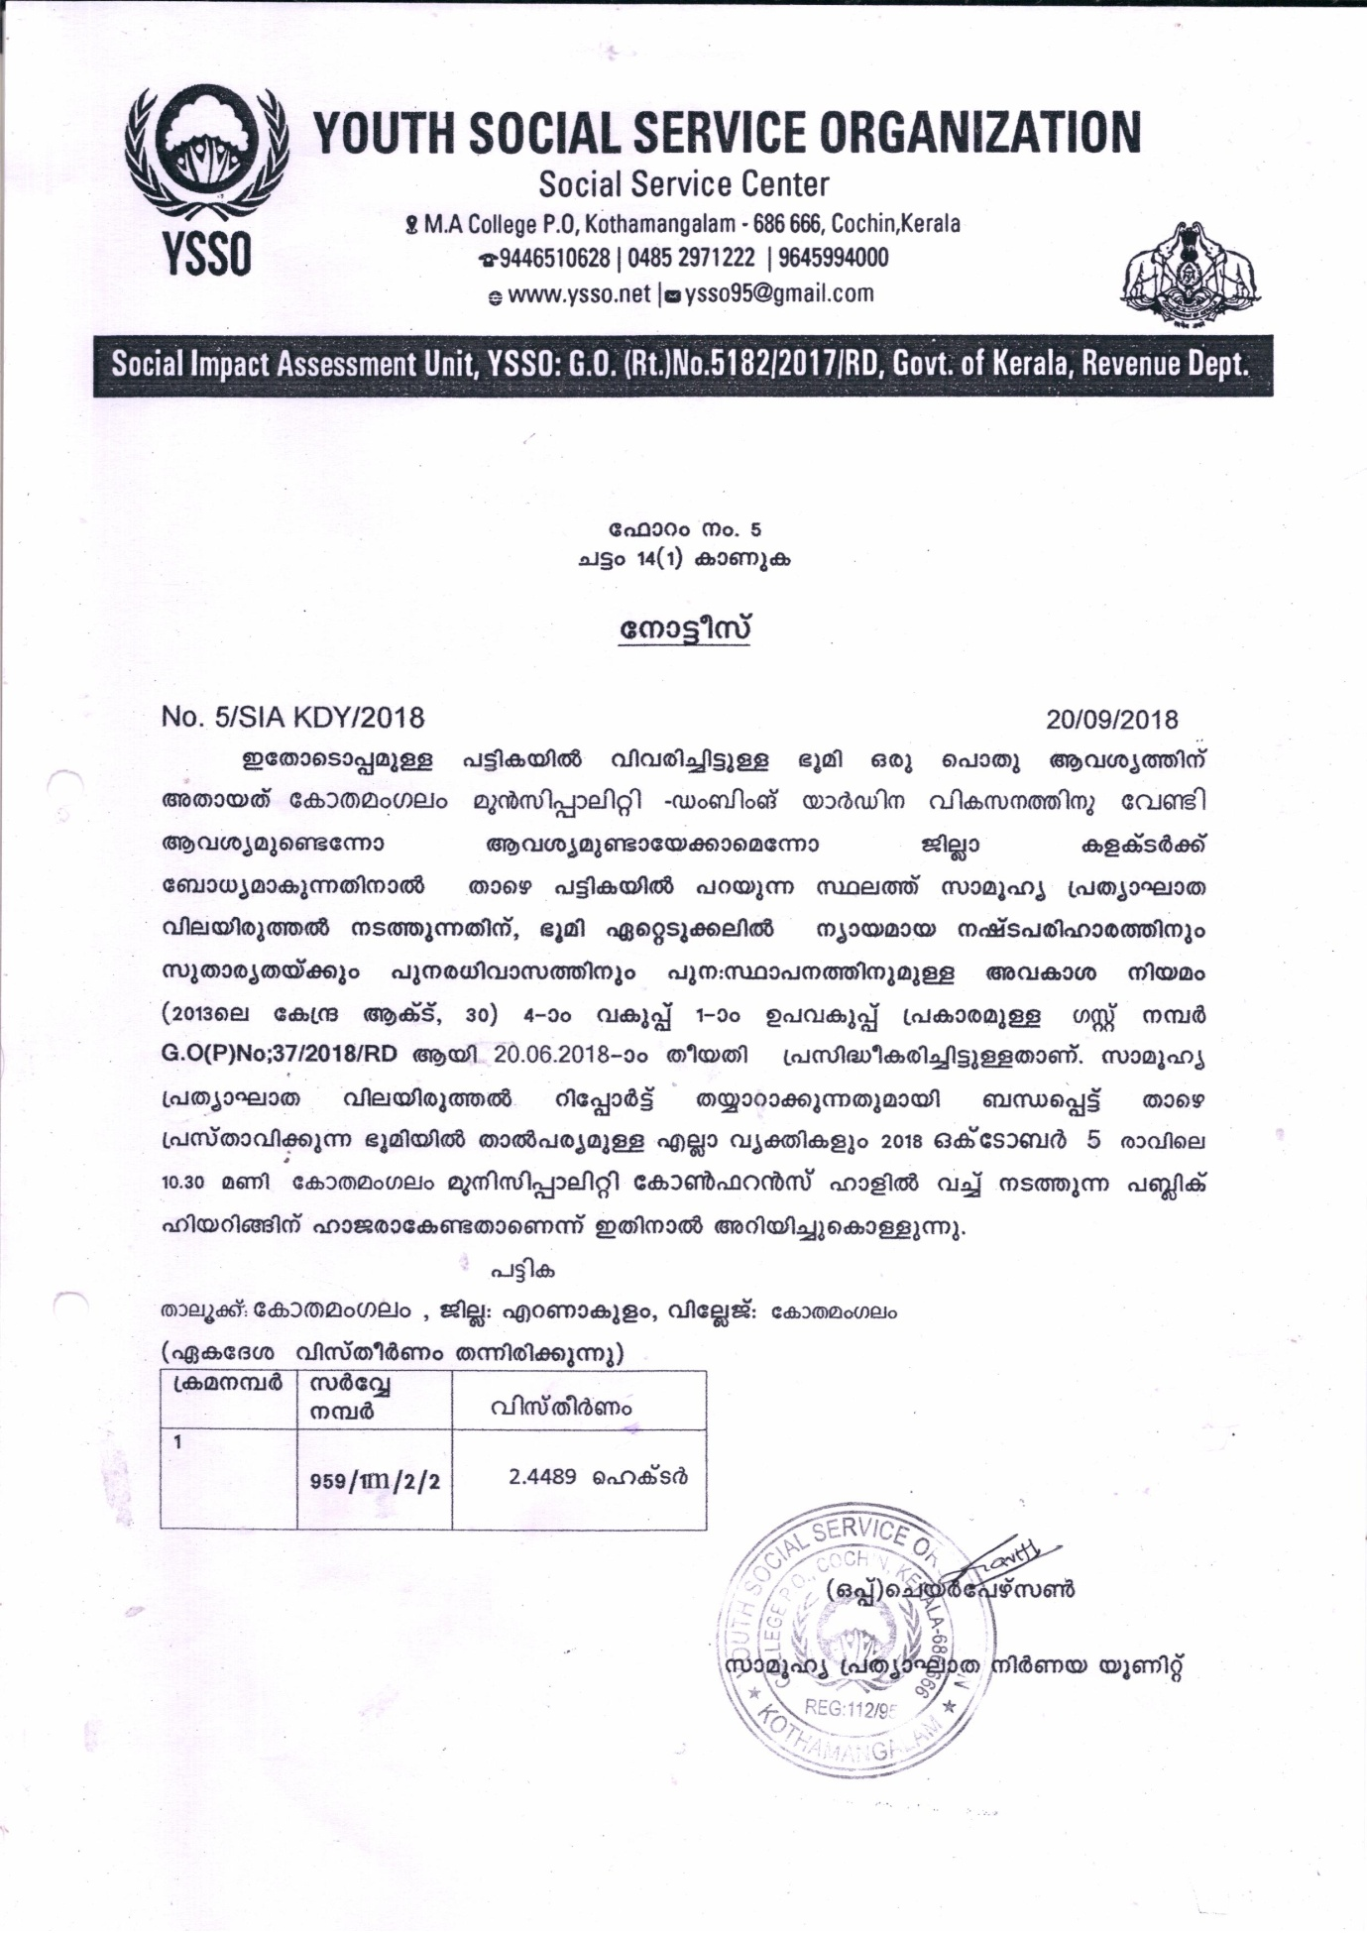

Annexure 5 List of participants-officials and affected families

